I am very disappointed in the Time Series Model Builder project. I have the following comments:

1. There are 144 rows in the data file (VERU_9_26_2022_144.csv). The code that was generated set the value of “seriesLength” to 2118. The documentation states that “seriesLength” is “The length of series that is kept in buffer for modeling (parameter N)”. What the does that mean? The value of 2118 does not make sense. Please explain.
2. The code that was generated set “windowSize” to 50. I assume that “windowSize” and “seriesLength” ae hyper-parameters. Is that true? If so, it would sure be nice if you guys would share that code that generated the values.
3. Model Builder gives the option to plot the error curve. That is necessary, but not sufficient. A plot of the predicted values is what researchers want to see. A table is not good enough. If you plot the predicted values generated by Model Builder, you will see how bad the predictions are. Here is the plot of the predictions. The red dots are the predicted values:

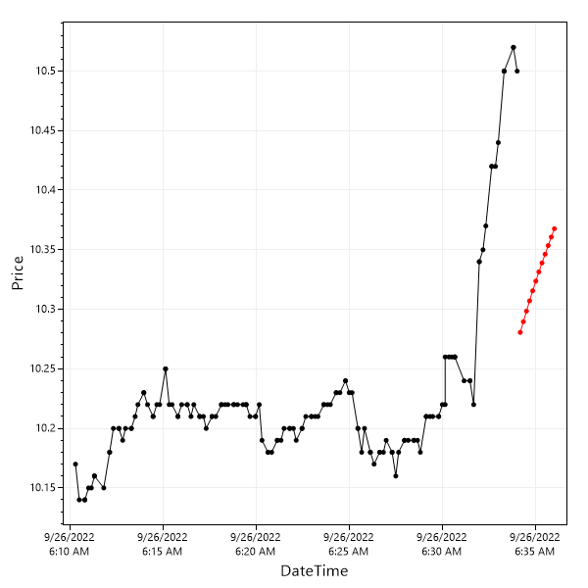

No cigar!

Either there is a serious bug in Model Builder, or the “SsaForecast” algorithm is worthless.

I give this project a grade of D-.

I have put the reproducible source code on GitHub so you can see the data file and code.

[CBrauer/Poor-Performance-of-ModelBuilder (github.com)](https://github.com/CBrauer/Poor-Performance-of-ModelBuilder)

Charles Brauer